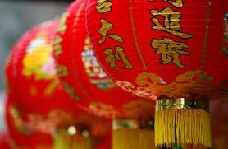
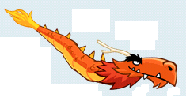
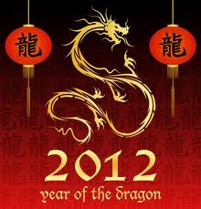
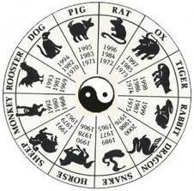
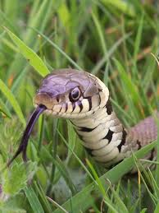
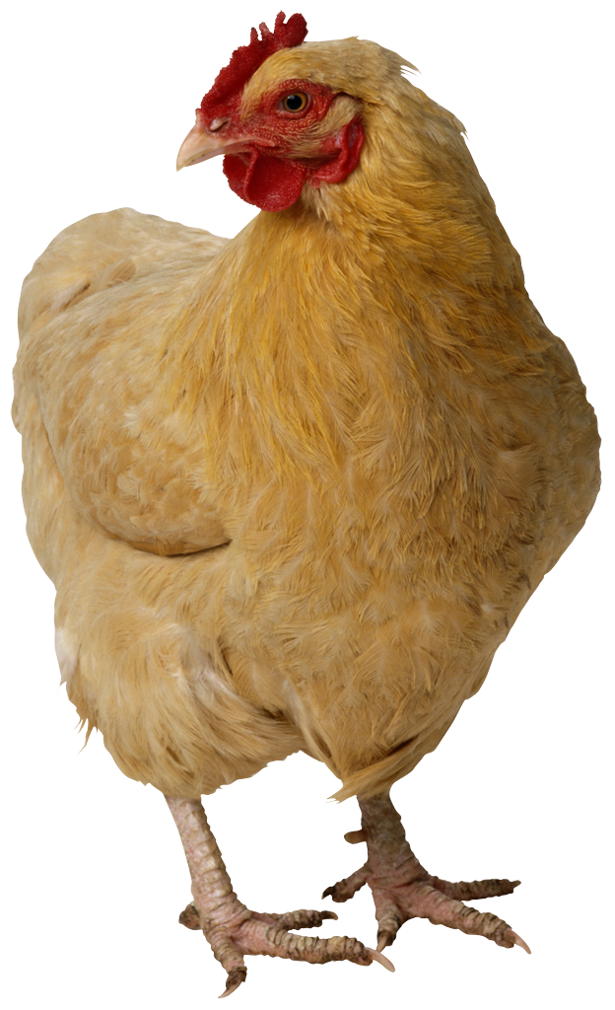
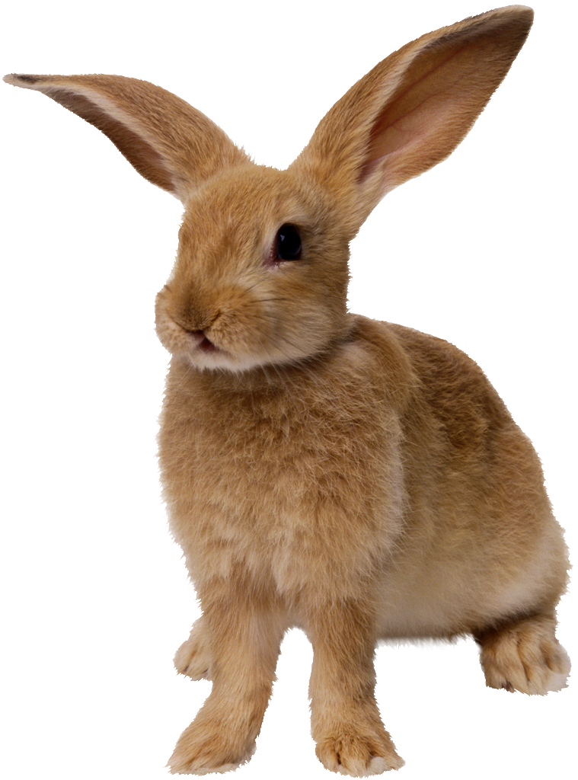
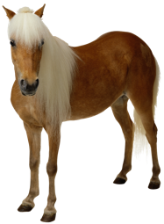
  - Chinese New Year is a Chinese holiday, celebrated in January, but the date changes every year. it is a lot like North American New Year, but with many differences. Lanterns are hung up, people dress up as dragons, and give each other money in red envelopes, for prosperity. They have parades and celebrations all night, with confetti everywhere, street dancers, people in dragon costumes, and fireworks set off near every shop for good luck. The dragon plays a big role in Chinese New Year, because it is a sacred animal in China. It represents good luck. The other animals of the Zodiac also play roles.
Chinese New Year:

Dragons and Chinese New Year

+

The Zodiac is a calendar that tells you which year belongs to a certain animal. For example, this year, 2012, is the year of the dragon. Last year, 2011, was the year of the ox. There are 12 animals on the Zodiac: the dragon, the tiger, the rat, the pig, the snake, the ox, the horse, the rabbit, the monkey, the sheep, the dog, and the rooster. The legend of the Zodiac is the story, about how a Chinese god invited all the animals on Earth, to come to his palace. But the only animals that came, were the 12 animals listed above. To reward them, the god gave them each a special year. I was born January 27th 2000, so I am a rabbit.

The Chinese calendar of animals.

The Zodiac:
+
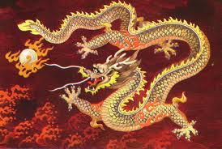
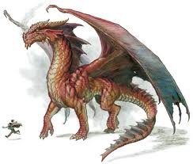
Dragons are mythical creatures. They have the ability to breathe fire. There are 2 types of dragons: Eastern dragons, and Western dragons. Western dragons are the kind we commonly see in movies and books. They have four legs, horns and spikes, and bat-like wings. Eastern dragons are from China, and most of Asia. They are more snake-like, and have antlers, fur and scales, and a long mustache. They are the same creature, but look different in different cultures. In China, dragons are sacred animals, and represent good luck. On Chinese New Year, it is common to see people dressed up as Eastern dragons.

The Dragon:
+
+

